Missing at Random (MAR) Analysis Report
Generated on: 2026-04-28 13:01:05
Dataset: 301,712 rows × 18 columns

1. Executive Summary
• Total missing values: 89,748 (1.65% of all data)
• Variables with missing data: 7 out of 18
• MAR supported for: 6 variables

2. Dataset Overview
Metric | Value
Number of Rows | 301,712
Number of Columns | 18
Total Missing Values | 89,748
Overall Missing Rate | 1.65%

3. Missing Data Summary
Variable | Data Type | Missing Count | Missing %
Birth_Weight(grams) | float64 | 33,542 | 11.12%
Birth_Order2.0 | float64 | 27,218 | 9.02%
Birth_Order | str | 27,218 | 9.02%
Race_of_Father | str | 1,231 | 0.41%
Race_of_Mother | str | 520 | 0.17%
Marital_Status | str | 17 | 0.01%
Gender | str | 2 | 0.00%

4. Missing at Random (MAR) Analysis Results

4.1 Variable: Gender
Missing Statistics:
• Missing values: 2 (0.00%)
• Data type: str
MAR Determination: NO - No MAR evidence found
No statistically significant associations were found between missingness in "Gender" and other observed variables. This pattern suggests either Missing Completely at Random (MCAR) or Missing Not at Random (MNAR).

4.2 Variable: Birth_Weight(grams)
Missing Statistics:
• Missing values: 33,542 (11.12%)
• Data type: float64
MAR Determination: YES - Missing at Random supported
Missingness in "Birth_Weight(grams)" is significantly associated with 4 other observed variable(s) in the dataset, satisfying the MAR condition.
- Associated Variables:
Associated Variable | Type | Statistical Test | P-value
Birh_Year | numerical | Mann-Whitney U | 0.0000
Birh_Year 2.0 | numerical | Mann-Whitney U | 0.0000
Birth_Month.0 | numerical | Mann-Whitney U | 0.0000
Age of Mother | numerical | Mann-Whitney U | 0.0000

4.3 Variable: Birth_Order2.0
Missing Statistics:
• Missing values: 27,218 (9.02%)
• Data type: float64
MAR Determination: YES - Missing at Random supported
Missingness in "Birth_Order2.0" is significantly associated with 4 other observed variable(s) in the dataset, satisfying the MAR condition.
- Associated Variables:
Associated Variable | Type | Statistical Test | P-value
Birh_Year | numerical | Mann-Whitney U | 0.0000
Birh_Year 2.0 | numerical | Mann-Whitney U | 0.0000
Birth_Month.0 | numerical | Mann-Whitney U | 0.0000
Age of Mother | numerical | Mann-Whitney U | 0.0015

4.4 Variable: Birth_Order
Missing Statistics:
• Missing values: 27,218 (9.02%)
• Data type: str
MAR Determination: YES - Missing at Random supported
Missingness in "Birth_Order" is significantly associated with 4 other observed variable(s) in the dataset, satisfying the MAR condition.
- Associated Variables:
Associated Variable | Type | Statistical Test | P-value
Birh_Year | numerical | Mann-Whitney U | 0.0000
Birh_Year 2.0 | numerical | Mann-Whitney U | 0.0000
Birth_Month.0 | numerical | Mann-Whitney U | 0.0000
Age of Mother | numerical | Mann-Whitney U | 0.0015

4.5 Variable: Marital_Status
Missing Statistics:
• Missing values: 17 (0.01%)
• Data type: str
MAR Determination: YES - Missing at Random supported
Missingness in "Marital_Status" is significantly associated with 3 other observed variable(s) in the dataset, satisfying the MAR condition.
- Associated Variables:
Associated Variable | Type | Statistical Test | P-value
Birh_Year | numerical | Mann-Whitney U | 0.0000
Birh_Year 2.0 | numerical | Mann-Whitney U | 0.0000
Age of Mother | numerical | Mann-Whitney U | 0.0000

4.6 Variable: Race_of_Mother
Missing Statistics:
• Missing values: 520 (0.17%)
• Data type: str
MAR Determination: YES - Missing at Random supported
Missingness in "Race_of_Mother" is significantly associated with 3 other observed variable(s) in the dataset, satisfying the MAR condition.
- Associated Variables:
Associated Variable | Type | Statistical Test | P-value
Birh_Year | numerical | Mann-Whitney U | 0.0000
Birh_Year 2.0 | numerical | Mann-Whitney U | 0.0000
Age of Mother | numerical | Mann-Whitney U | 0.0000

4.7 Variable: Race_of_Father
Missing Statistics:
• Missing values: 1,231 (0.41%)
• Data type: str
MAR Determination: YES - Missing at Random supported
Missingness in "Race_of_Father" is significantly associated with 3 other observed variable(s) in the dataset, satisfying the MAR condition.
- Associated Variables:
Associated Variable | Type | Statistical Test | P-value
Birh_Year | numerical | Mann-Whitney U | 0.0000
Birh_Year 2.0 | numerical | Mann-Whitney U | 0.0000
Age of Mother | numerical | Mann-Whitney U | 0.0000

5. Missing Data Visualizations
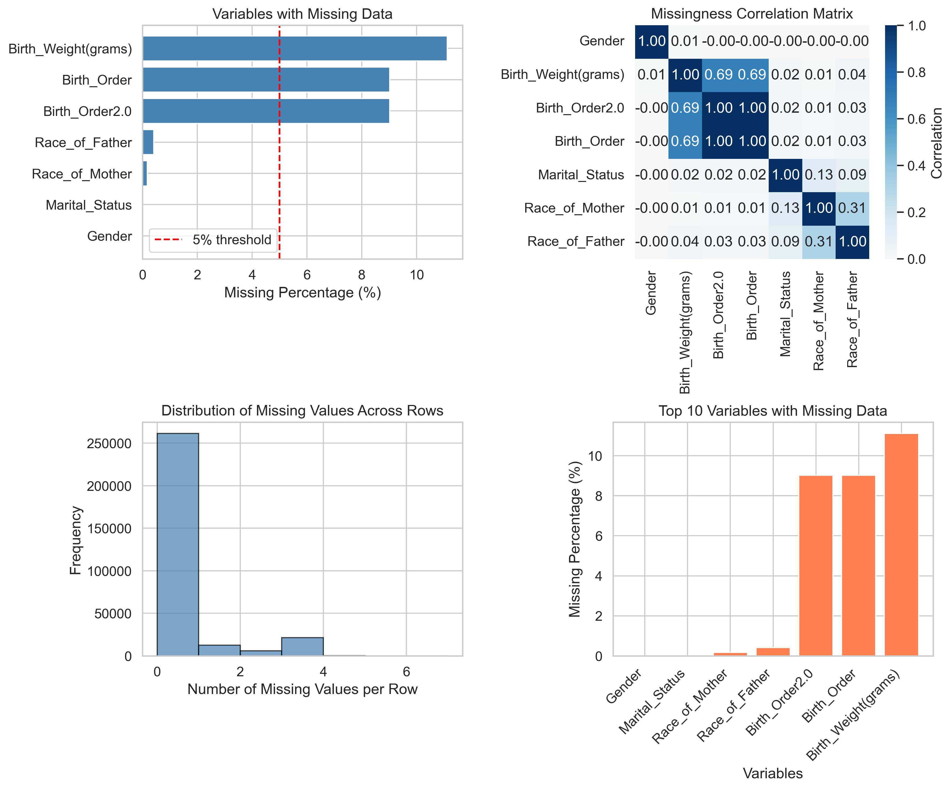
Figure 1: Missing Data Visualizations

6. Recommendations for Missing Data Handling

For MAR Variables:
- Since missingness in these variables depends on observed data, use:
- Multiple Imputation by Chained Equations (MICE)
- Full Information Maximum Likelihood (FIML)
- Expectation-Maximization (EM) Algorithm
Variables to impute: Birth_Weight(grams), Birth_Order2.0, Birth_Order, Marital_Status, Race_of_Mother and 1 more

For Variables without MAR Evidence:
- For these variables, conduct additional tests to determine between MCAR and MNAR:
- Little's MCAR Test - to test for MCAR
- Sensitivity Analysis - to assess MNAR impact
- Pattern-Mixture Models - for MNAR handling

7. Conclusion
Based on the analysis, 6 out of 7 variable(s) with missing data demonstrate MAR patterns. This indicates that missingness is systematically related to observed variables, making multiple imputation an appropriate strategy.
Overall missing data rate is 1.65%, which is low and requires appropriate handling to avoid biased results.

8. Appendix: Detailed Statistics

Complete MAR Results
Variable | MAR Supported | Number of Associations
Gender | No | 0
Birth_Weight(grams) | Yes | 4
Birth_Order2.0 | Yes | 4
Birth_Order | Yes | 4
Marital_Status | Yes | 3
Race_of_Mother | Yes | 3
Race_of_Father | Yes | 3

